Question 1 Calc Assumed (6 marks)

The West Australian Newspaper cost 5 cents in 1969, and cost 60 cents in 1993.
(a) Assuming geometric growth, show that the % rate of increase per year, correct
to 1 decimal place, of the cost of a newspaper over that period is 11.4%. (3 marks)
(b) Which one of the following models best describes the situation?
In each case, n is years starting at 1969, so for 1969, n= 1 etc
(i) Cost = 5 (1.114)^{n–1}
(ii) Cost = 5 (0.114)^{n–1}
(iii) Cost = 60(–1.114)^{n–1}

The correct model is (1 mark)
The cost in 2015 was $2.70.

(c) Is $2.70 more, less, or what you would have expected?
Explain your answer showing some supporting calculations using
the information in (a). (2 marks)

Solutions Question 1 Calc Assumed (6 marks)

(a) T₁ = a = 5 and T₂₄ = ar²³ = 60
r²³ = 12
r = 1.114
Rate is 11.4% p.a.

(b) The correct model is (i)

(c) 5(1.114)⁴⁵ = $6.44
So $2.70 is much less than expected. [6]

Question 2 Calc Assumed (8 marks)

Agatha embarks on a 4 year savings plan. She invests $500 per month with an investment group,
where she earns 12% p.a. compounding monthly. She produces the following table using her
knowledge of simple percentages.
Month | Opening Balance  $ | Interest  $ | Closing Balance  $
1 | 500 | 5 | 505
2 | 1005 | 10.05 | 1015.05
3 | 1515.05 | a | b
4 | c
5
6
7
8

(a) Determine a, b and c. (3 marks)
(b) Why will 48 lines be needed in the table to show all transactions? (1 mark)
Agatha’s friend, Martha, uses the following recursive definition to model the situation.
A_{n+1} = 1.01A_{n} + 500 where A₁ = 500
(c) State the first 3 terms, and term 49, using this model. (2 marks)
(d) Determine the amount of interest Agatha will have earned in that 4 year period,
ie at the time she has just made her 49th deposit. (2 marks)

Solutions Question 2 Calc Assumed (8 marks)

(a) a = $15.15, b = $1530.20, c = $2030.20

(b) 4 years = 48 months. So 48 lines required.

(c) A₁ = 500, A₂ = 1005, A₃ = 1515.05
A₄₉ = 31 417.42

(d) 31 417.42 – (49 x 500)
= $6 917.42 [8]

Question 3 Calc Assumed (7 marks)

Dylan borrows $15 000 to buy a car at 8% pa with interest compounded annually.

(a) State a recursive definition which represents that loan. (2 marks)

(b) Hence, or otherwise, determine how much Dylan owes after 3 years, if no
repayments have been made. (2 marks)

(c) Calculate the effective rate of interest if the loan was compounded monthly rather
than annually.
State your answer as a percentage rounded to two decimal places. (3 marks)

Solutions Question 3 Calc Assumed (7 marks)

(a) T_{n+1} = (1.08) T_{n}, T₀ = 15 000

(b)
n | Tn
0 | 15 000
1 | 16 200
2 | 17 496
3 | 18 895.68
He owes $18 895.68
Table or calculator
(c) e = 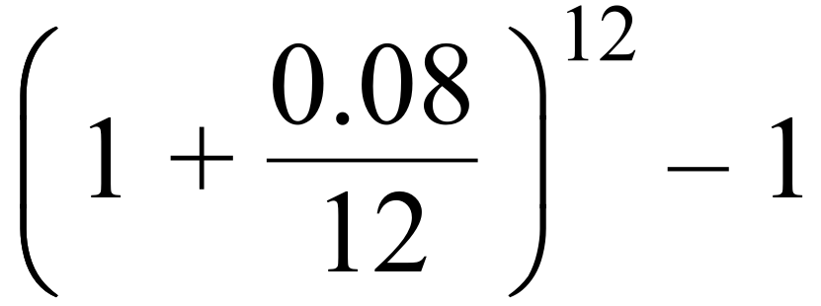
= 0.082999
= 8.30% p.a. [7]

Question 4 Calc Free (6 marks)

Erica buys a new car for $30 000.

In the first year it depreciates by 20% .

(a) What is the car worth after 1 year? (1 mark)

From then on, it depreciates by 10% per year
(b) What is the car worth after
(i) 2 years (1 mark)

(ii) 3 years (1 mark)

(iii) n years (1 mark)

To offset this loss in value, Erica decides to cut costs by reducing her petrol
consumption by 10%. However petrol prices increase by 10%.

(c) What will be the overall effect from these 2 changes? (2 marks)

Solutions Question 4 Calc Free (6 marks)

Original Value: V0 = 30 000
(a) After 1 year: V1 = 30 000 (0·8) = 24 000
(b) (i) After 2 years: V2 = 24 000 (0·90)1 = 21 600
(ii) After 3 years: V3 = 24 000 (0·90)2 = 19 440
(iii) After n years: Vn = 24 000 (0·90)n–1
(c) Let x be the original amount spent.
x(0·9) . (1·1)
This represents a 1% reduction in spending [6]

Question 5 Calc Free (7 marks)

Solutions Question 5 Calc Free (7 marks)

Question 6 Calc Free (4 marks)

Solutions Question 6 Calc Free (4 marks)

Question 7 Calc Assumed (8 marks)

Solutions Question 7 Calc Assumed (8 marks)

Question 8 Calc Assumed (7 marks)

Solutions Question 8 Calc Assumed (7 marks)

Question 9 Calc Assumed (8 marks)

Solutions Question 9 Calc Assumed (8 marks)

